DOCUMENTATION

**DETAILS**

**TEAM MEMBERS**: S. SANJEEVIKUMAR

K.V. RAJAVEL

S. AAKASH

N.ANANDHA KUMAR

**DEGREE/BRANCH**: B.E/CIVIL ENGINEERING

**INSTITUTE NAME**: VELAMMAL COLLEGE OF ENGINEERING AND TECHNOLOGY VIRAGNOOR MADURAI-625 009

**SKILLS**: DIGITAL MARKETING

**Project Details**

**Mail**

* **E-mail**: ssconstruction2505@gmail.com
* **Password**: SSConstruction25

**Canva**

* **Brand Name**: SS Construction
* **Canva URL**:

<https://www.canva.com/design/DAFyblzVx9M/GXpGr_EpEM2M6ZM1sitZsA/edit?utm_content=DAFyblzVx9M&utm_campaign=designshare&utm_medium=link2&utm_source=sharebutton>

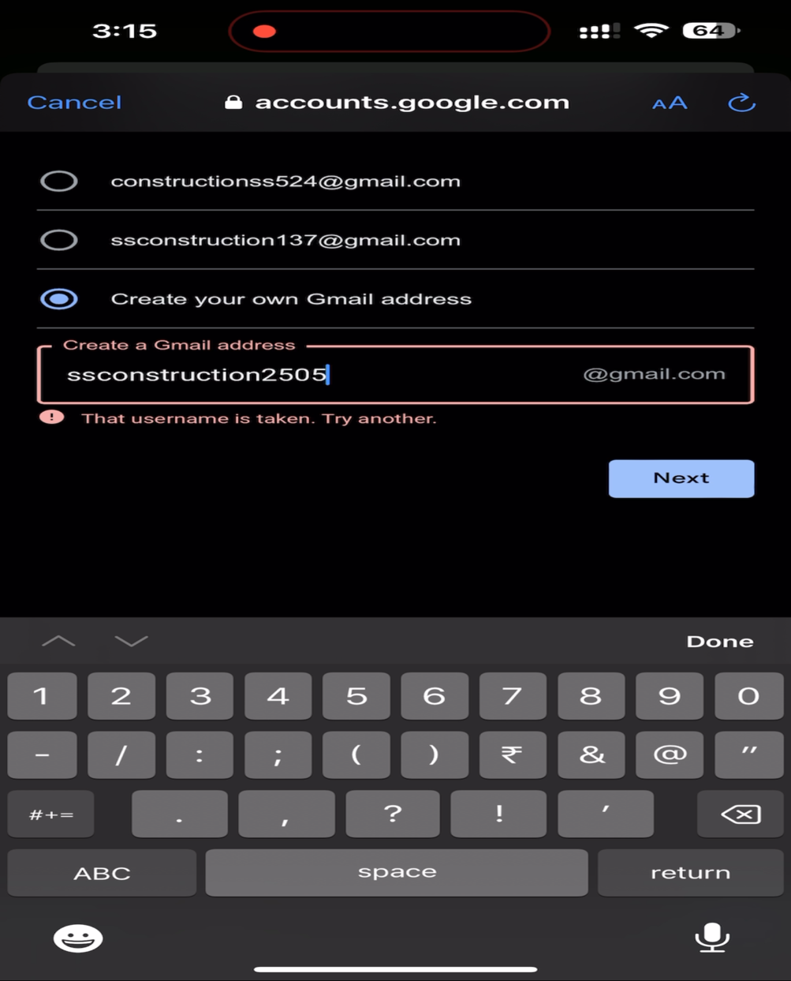Creating a mail id

Opening the Canva site

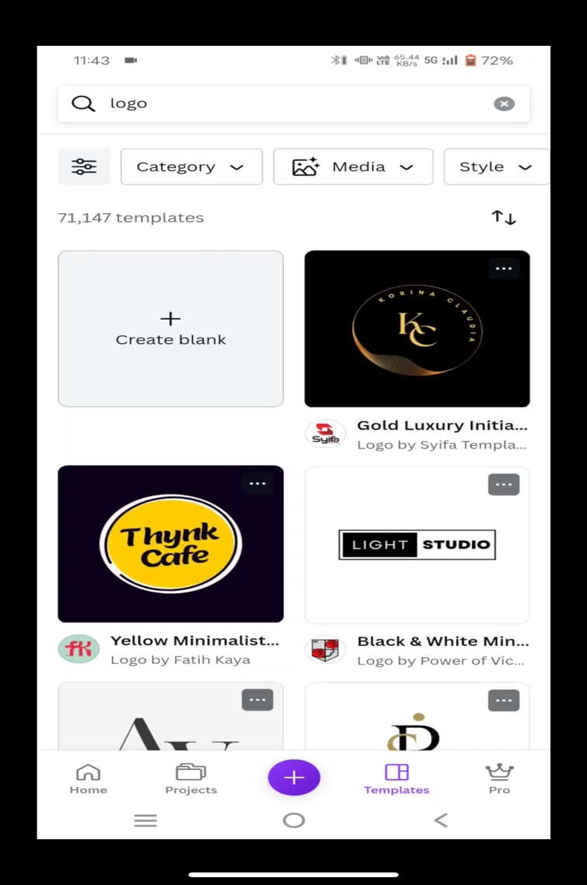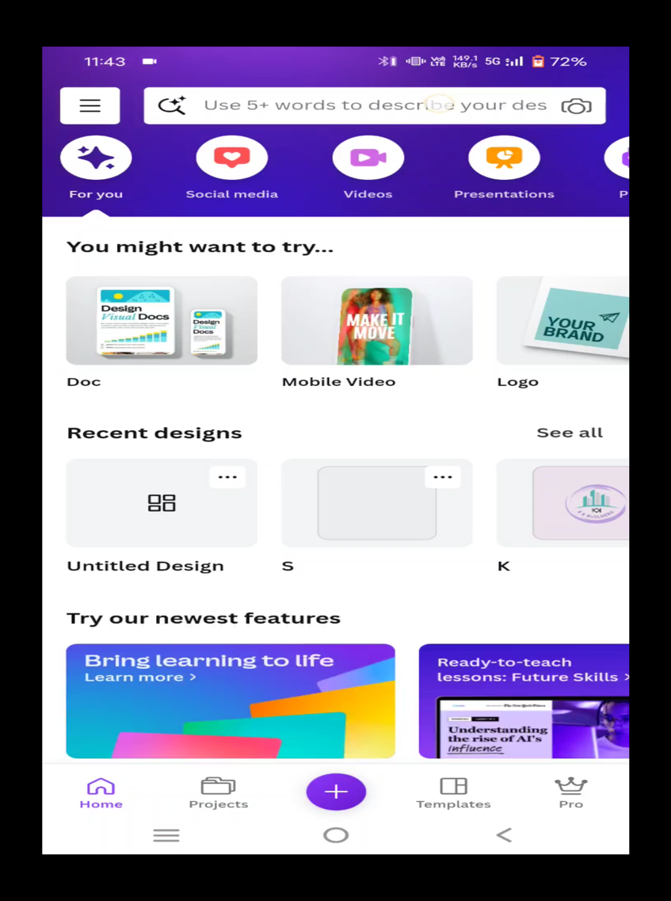

Opening a blank logo template



Selecting Background Shape

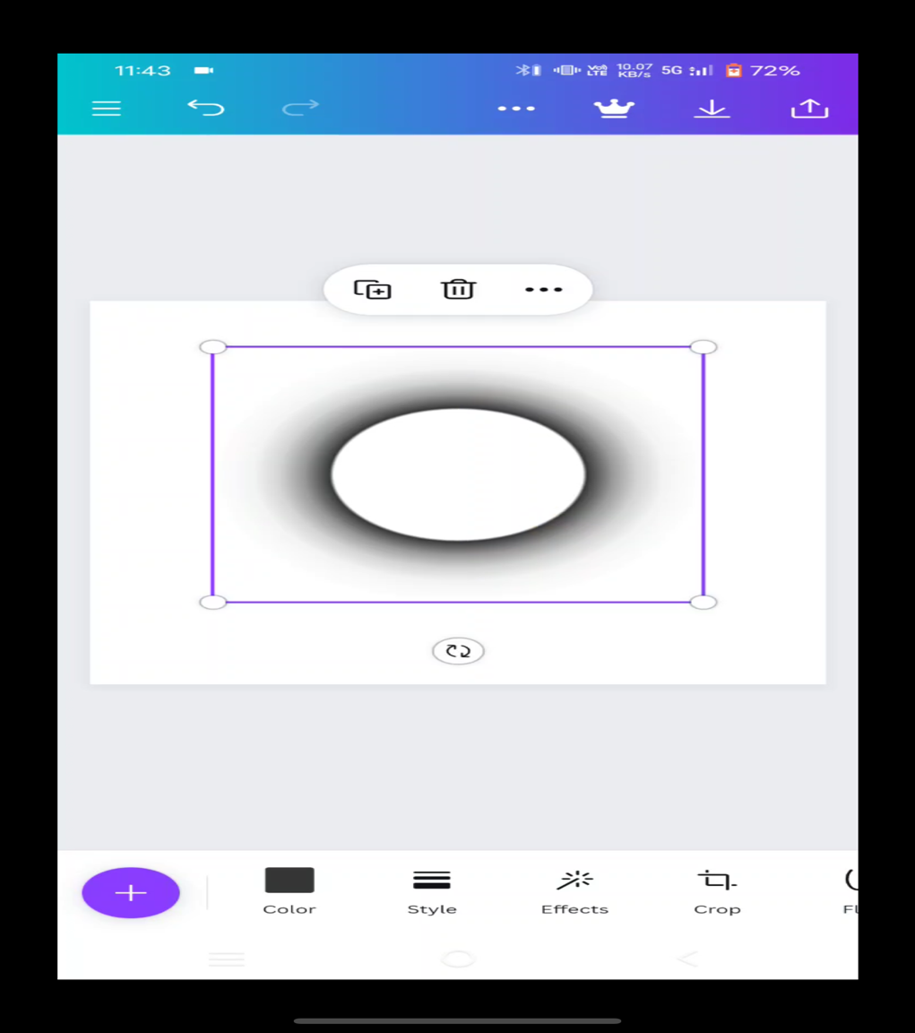

# Selecting Background Colour

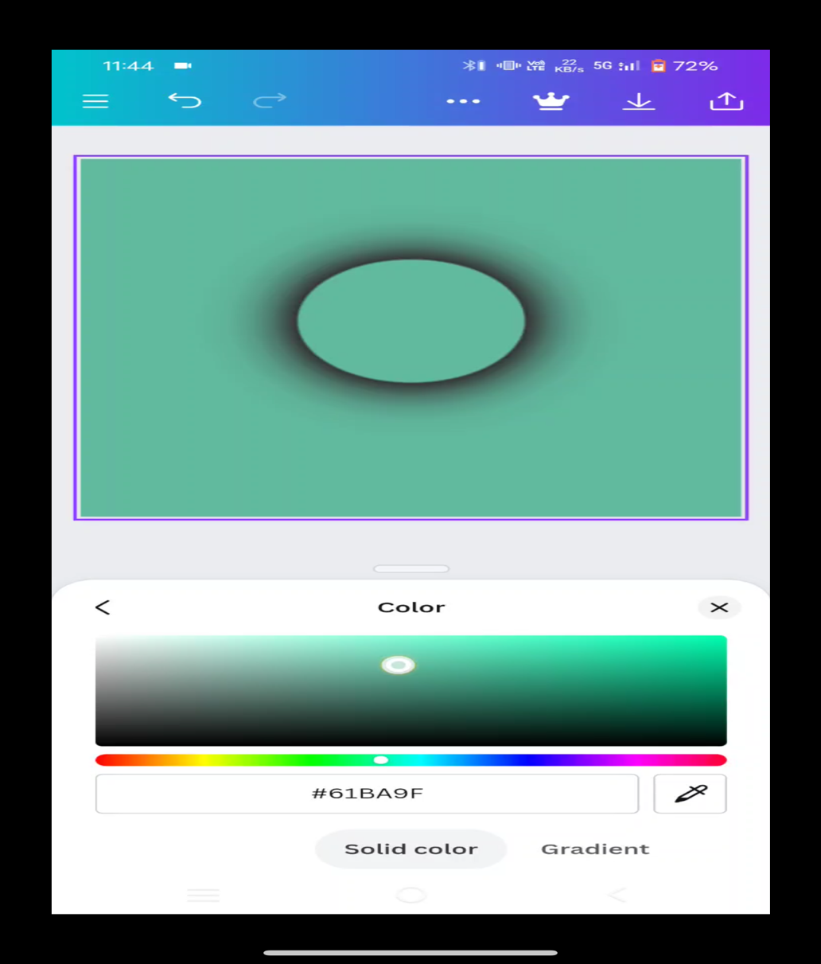

Selecting Background Image

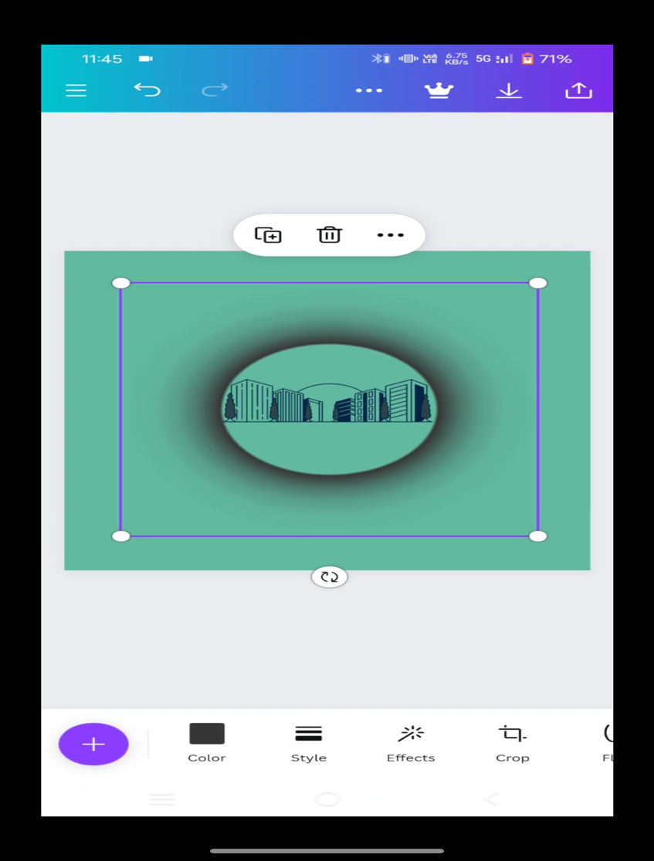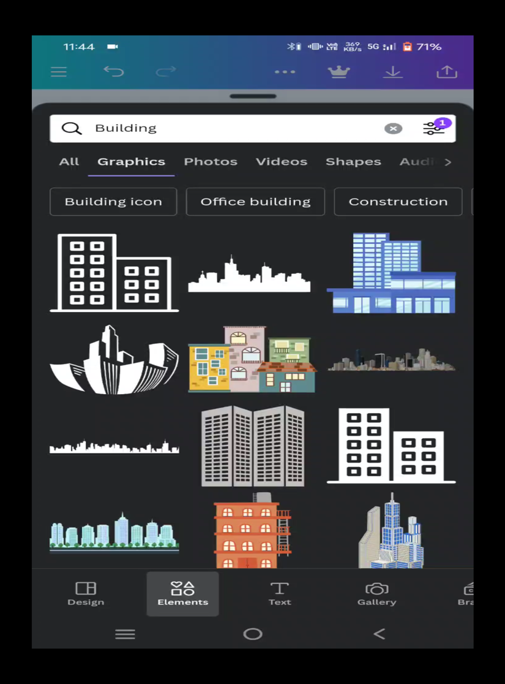

Choosing Letter for Logo and Font

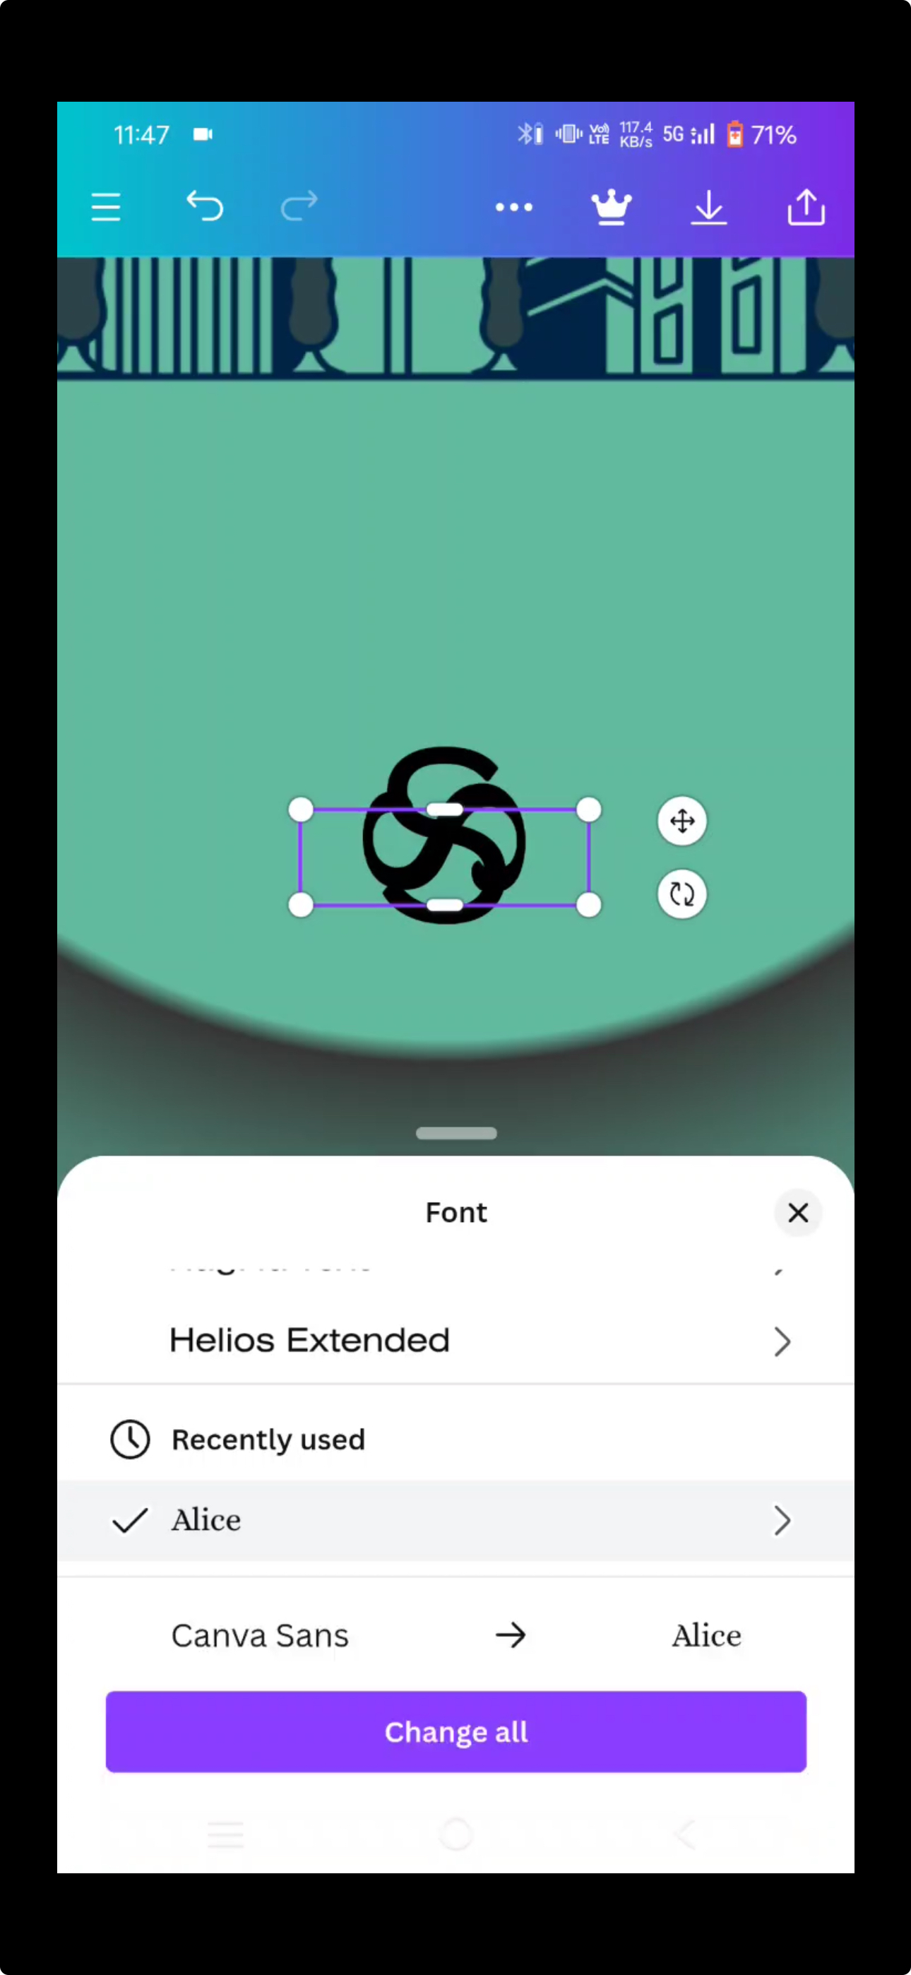

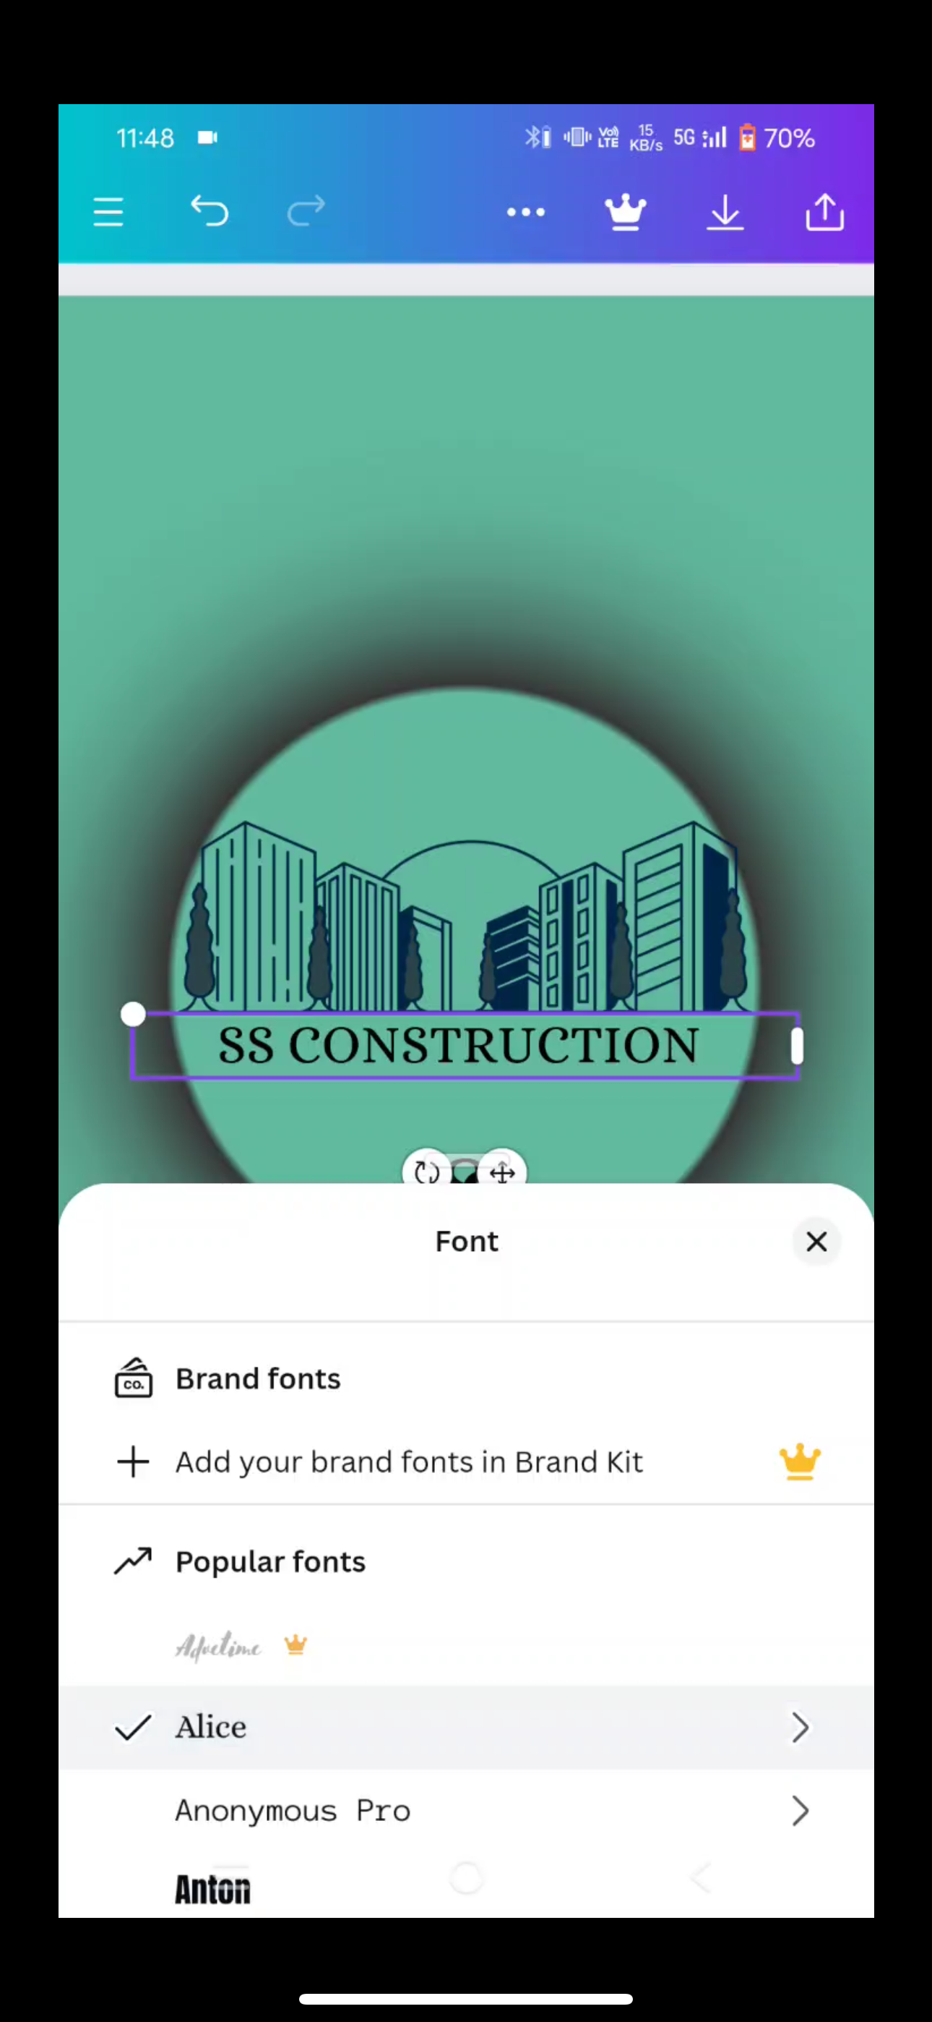 Inserting Our Brand Name and Font

# Our Final Logo Output

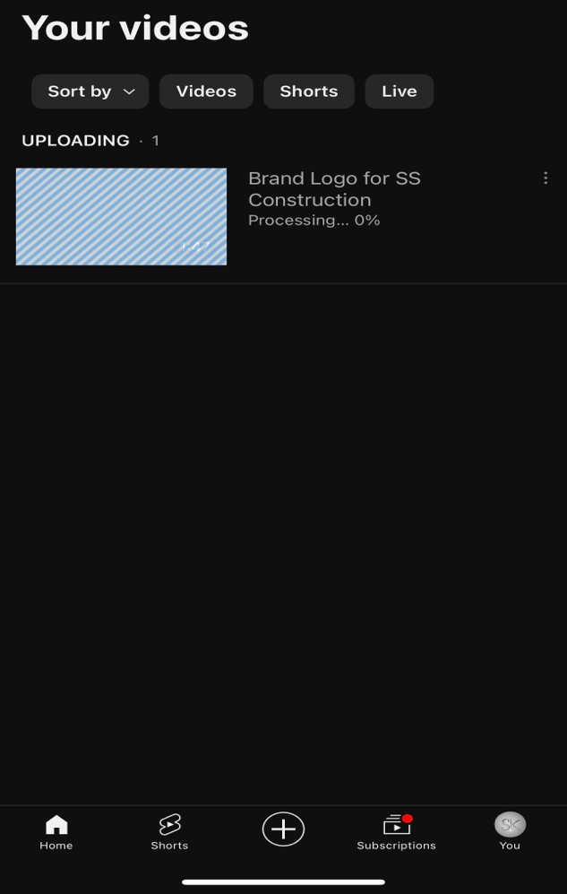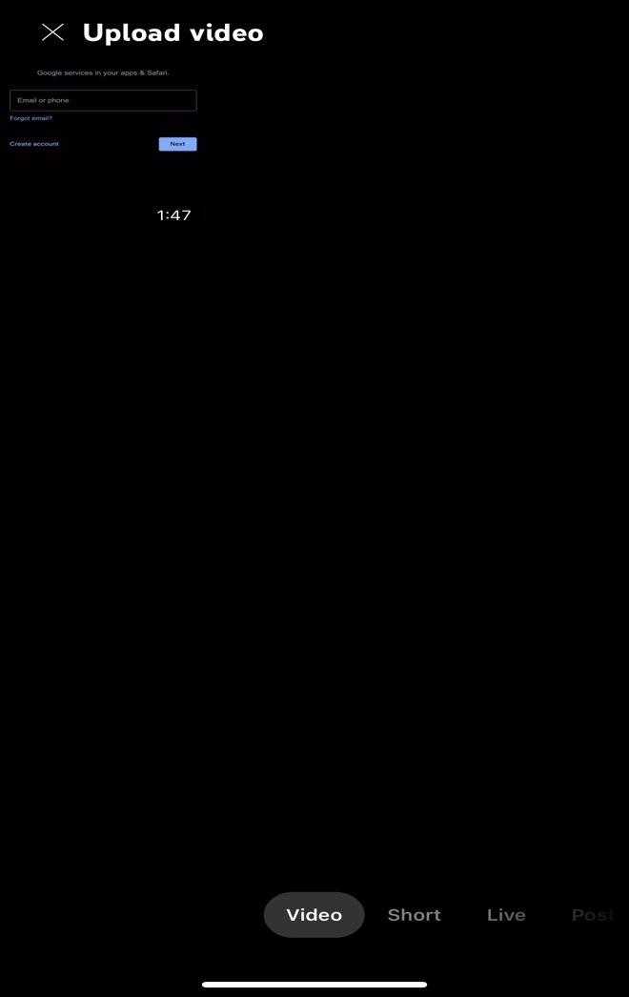Uploading the video in youtube

